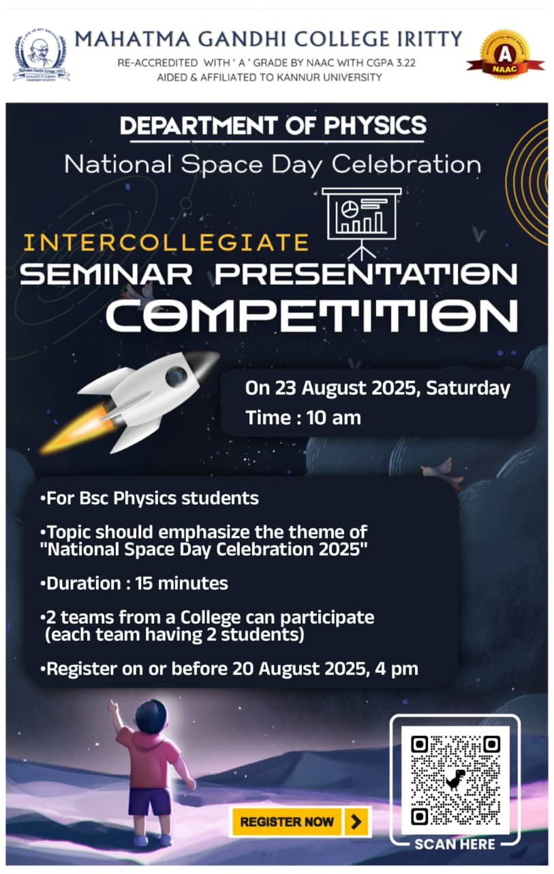
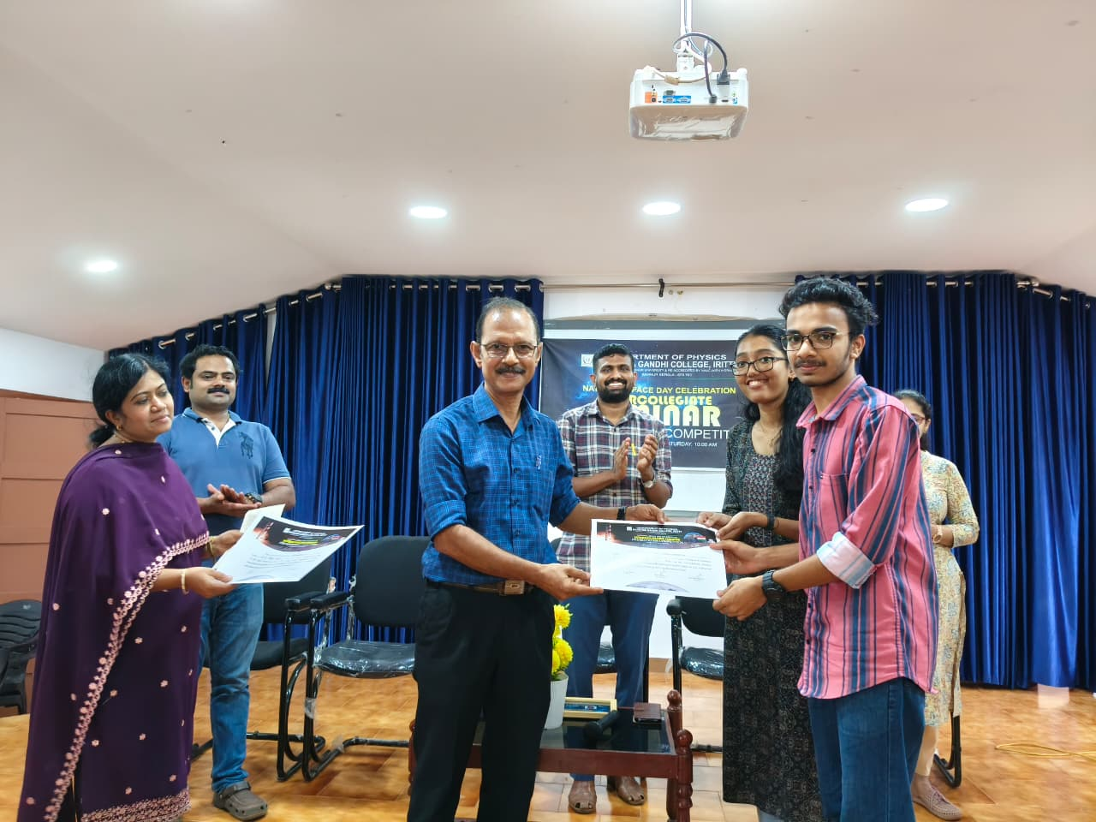
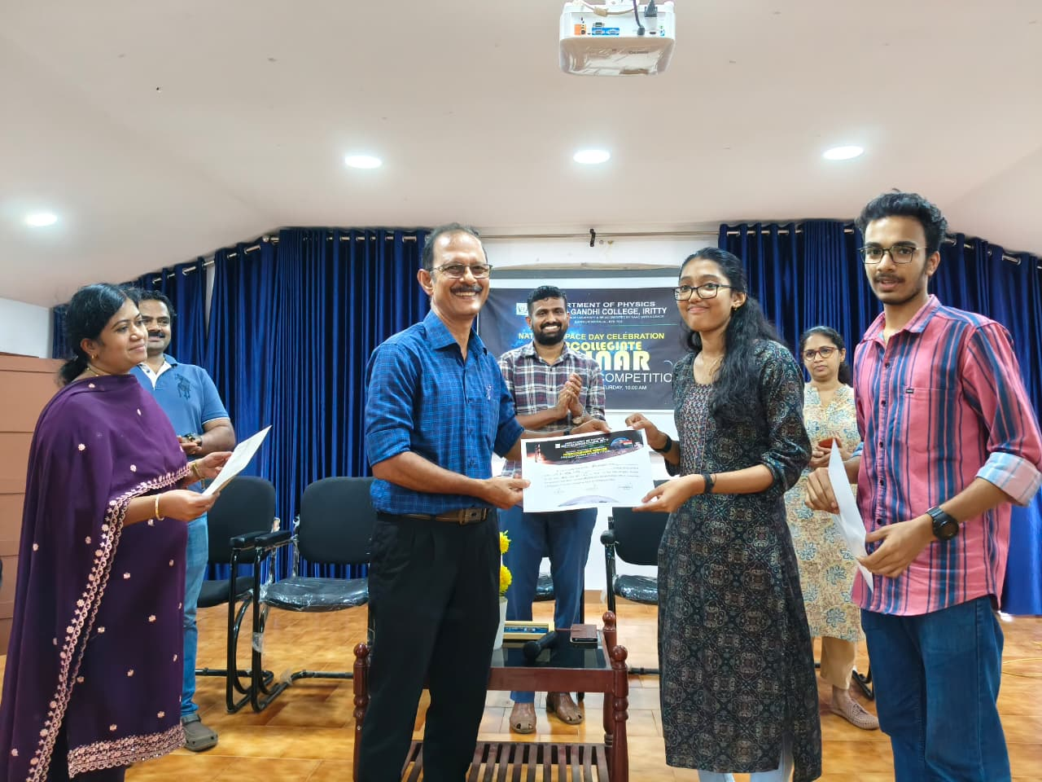
An Intercollegiate Seminar Presentation Competition was conducted on 23rd August, 2025 as part of National Space Day Celebration

.

First... Sharon & Vyshnavi, II BSc Physics, MG College

Second... SN College, Kannur
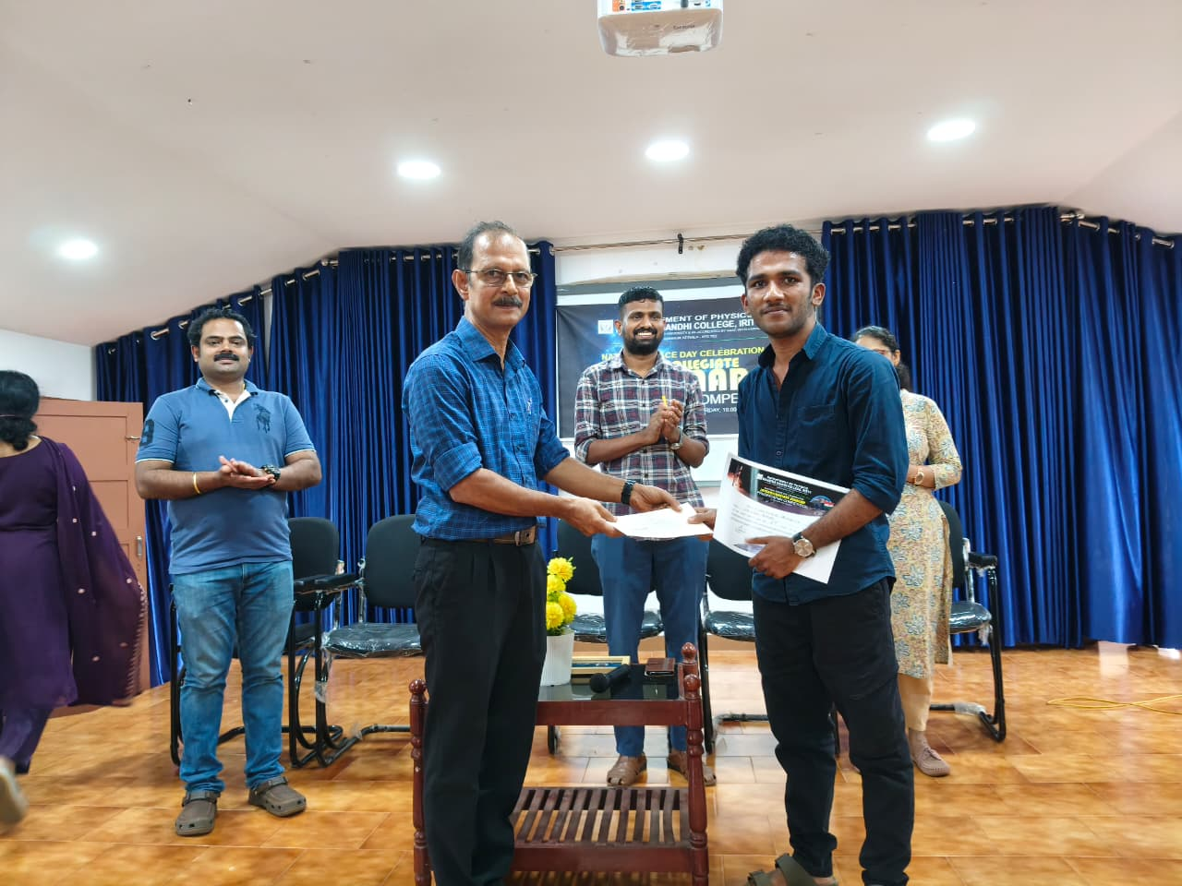
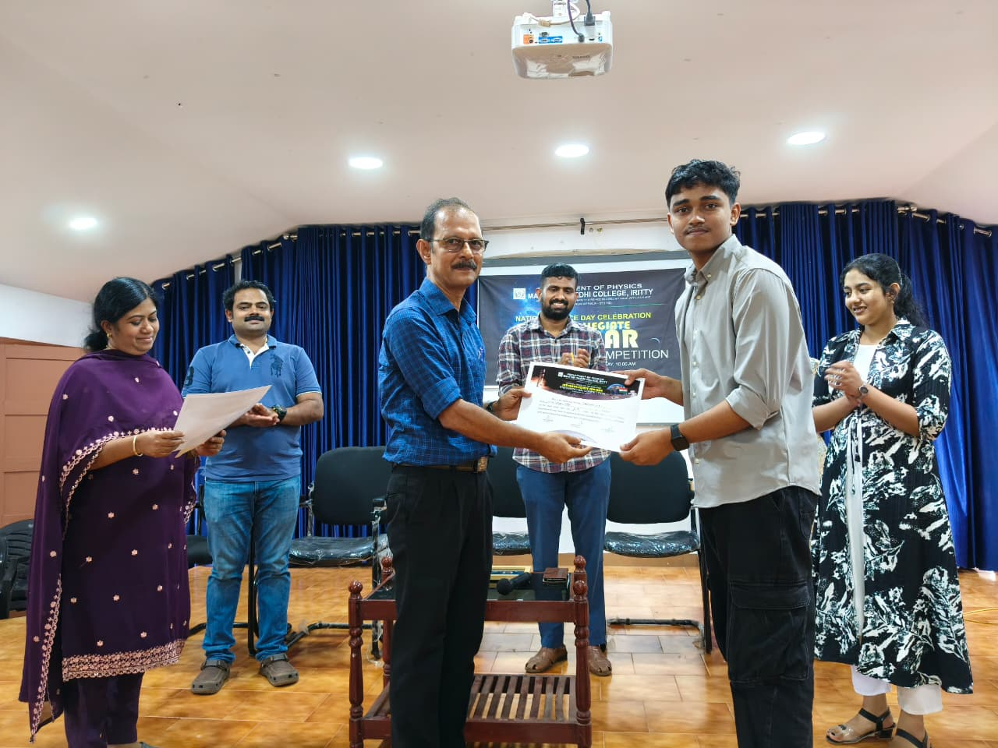
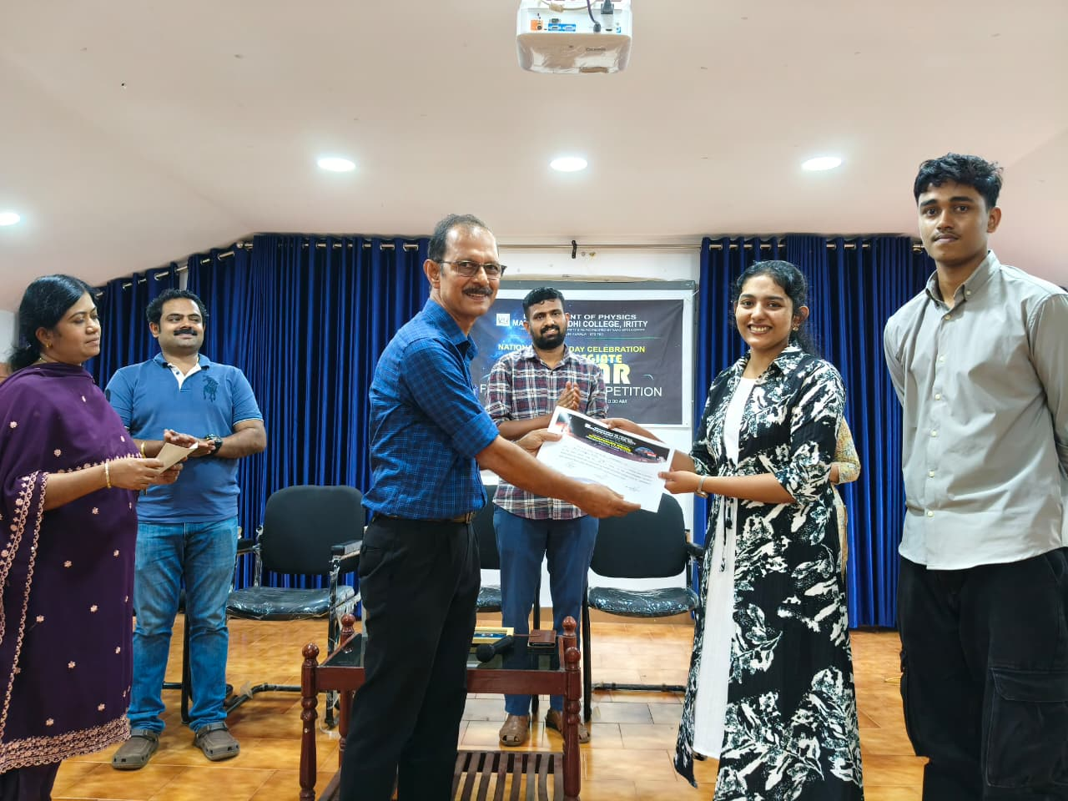

Third… Abhirami & Aravind (I BSc Physics) MG College

Prof Roy Thomas, Rtd HOD Physics, Nirmalagiri College, distributed the prizes

